Ngày thực hiện: 20/11/2015
Số tiết: 1

UNIT 4: HOW OFTEN DO YOU DO YOGA?

READING: HAVING FUN FOR FREE.
Main skill: Reading
Objectives: By the end of the lesson, students will be able to:
+Improve their reading skill: scanning and skimming skill.
+Enlarge the vocabulary about the leisure activities and famous places in some countries.
+Be able to talk about their hobbies and free time.
Teaching aids: pictures, blackboard, textbook, cassette, chalk, handouts
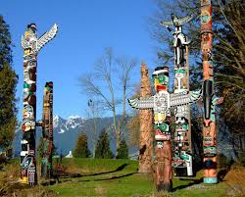
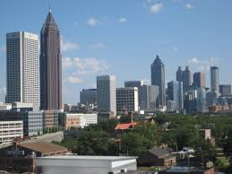
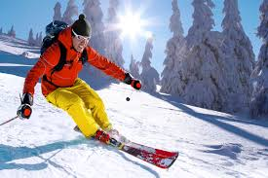
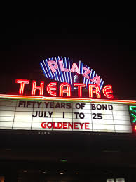
LESSON’S CONTENT | TIME | TEACHER’S ACTIVITIES | STUDENT’S ACTIVITIES
Pre-reading:  Warm up  While- reading  Post- reading | 10 mins  25 mins  15 mins | -Greeting.  -Teacher (T) asks Students (Ss) to close their books first.  -T shows photos of four countries and elicits Ss to give the names of these countries.  -T divides class into small groups.  -T delivers the handouts.  -T gives each group one specific question to discuss about famous sports in above countries.  -T asks students to choose the two most popular cities and sports for each following country given in the handouts.  -T asks a representative of each group to go on the board and write down the answers.  -T gives more information about the culture of some countries.  -T asks S to open the book.  -T focuses Ss to describe the pictures in the article.  -T asks these questions:  +What is the title talking about?  +Where are these places?  +What do you know about them?  -T plays the recording and has S read the article individually.  -T requests S to underline all the Vocabulary they don’t know.  -T writes down new vocabulary on the board, shows the pictures and explains the meanings.  Outdoor, movie theater, ski, terrific, downtown, wildlife, concert, totem-pole.  -T models to read aloud each word.  -T calls some S to practice pronouncing the new words.  -T has S to check the correct boxes.  -T checks answers.  -T asks Ss to focus on the four questions activity 3.  -T writes them on the board and reads them aloud to the class.  -T has Ss read the questions one at a time.  -T elicits the answer from the class.  -T calls some Ss to write the complete sentences on the board.  -T writes the following question on the board: What fun things can you do for free in your city?  -T elicits some answers from the class and writes down all the sentences on the board.  -T asks Ss to work in groups and to discuss the question.  -T elicits answers from each group.  -T asks Ss to write them on the board. | -Students close their book.  -Ss look at the photos and answer.  Expected answer: Japan, America, Canada, and Australia  -Ss work in group and discuss.  -Ss write down their answers on the board.  -Ss open their books.  -Ss answer these questions individually.  -Ss listen the recording and stay focused on the words they don’t know.  -Ss give T new words.  -Ss focus on how to pronounce new vocabulary and read aloud.  -Ss check the correct boxes.  Expected answer:  Brian: beaches, music, parks.  Sarah: markets, mountains, parks.  -Ss pay attention on the questions.  -Ss read and answer the question.  Expected answers:  1.A park.  2.In January.  3.You can ski in the mountain and swim in the ocean on the same day.  4.No, it isn’t.  -Ss give T some ideas to answer the question.  -Ss work in small group, exchange the ideas.  -Ss write them on the board.  Possible answers:  -You can go to the park.  -You can go to visit the museum.  -You can go to the outdoor markets.

.

TỔ TRƯỞNG BỘ MÔN GV SOẠN

Nguyễn Thị Minh Quý Phạm Thị Thu Hiền

CHOOSE THE TWO MOST POPULAR CITIES AND SPORTS FOR EACH COUNTRY.
SPORTS: SUMO, SKI, SOCCER, BASEBALL, FOOTBAL, TENNIS, BASKET BALL, ICE HOCKEY, KENDO
CITIES: SIDNEY, WASHINGTON DC, TOKYO, MELBOURNE, VANCOUVER, NEW YORK, TORONTO, OSAKA, SEOUL, BANGKOK

PICTURE 2
PICTURE 1
PICTURE 3
PICTURE 4
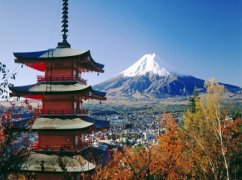
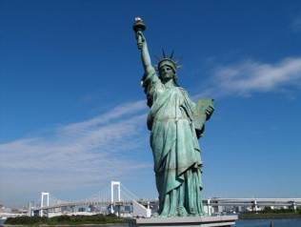
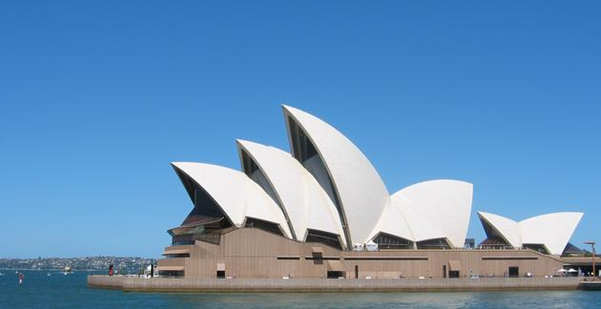


NAME

CITIES

SPORTS

